CIRCULAR

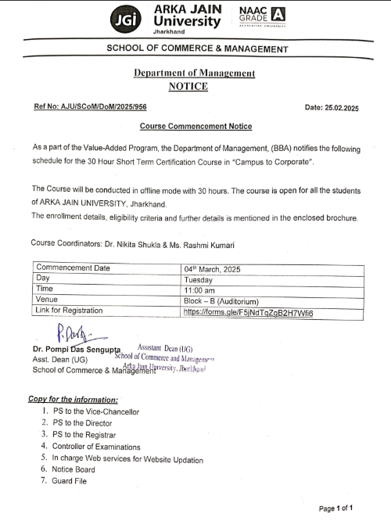

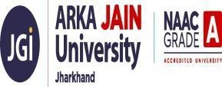

Campus to Corporate

Date of Event | 2025
Name of the Event | Campus to Corporate
Type of the Event | Skill Development Program and Participative Learning- Value Added Course
Conducted by | Department of Management (BBA)
Convener Name | Dr. Pompi Das Sengupta
Coordinator Name | Dr. Nikita Shukla & Ms. Rashmi Singh
No. of Participant | 100

OBJECTIVE: The primary objective of the Campus-to-Corporate program is to prepare students for a smooth transition from academic life to the professional corporate environment. The course aims to equip participants with the necessary skills, knowledge, and professional behavior expected in the industry, thereby enhancing their employability and confidence.

DETAILS:

The Department of Management organized a 30 Hours Value Added Course titled Campus-to-Corporate, commencing on 4th March 2025 at AJU Campus. The program featured Master Class Experts, offering a unique blend of industry expertise and academic knowledge. It was designed to bridge the gap between campus learning and workplace demands by focusing on essential areas such as professional communication, workplace etiquette, time and stress management, teamwork, leadership, problem-solving skills, understanding corporate culture and expectations, and resume building along with interview preparation. Through interactive workshops, case discussions, and real-world scenarios, participants gained practical insights to enhance their employability, boost their confidence, and secure a competitive edge in placement drives and early career progression.

TAKEAWAYS:

- Enhanced understanding of corporate work culture.
- Improved communication, presentation, and interpersonal skills.
- Increased confidence in facing interviews and corporate challenges.
- Better preparedness for professional roles after graduation.

Poster of the Event

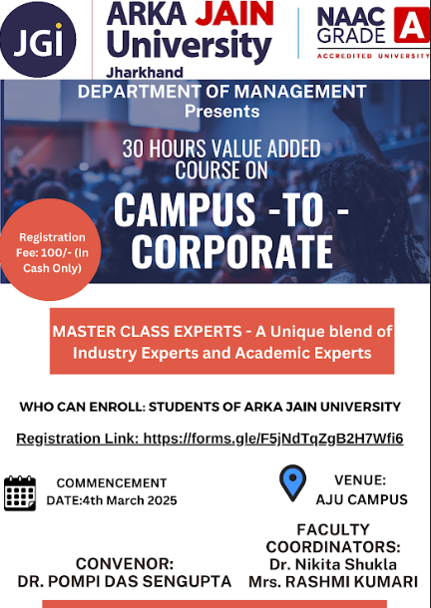

Figure 1 (a): Poster of Value Added Course

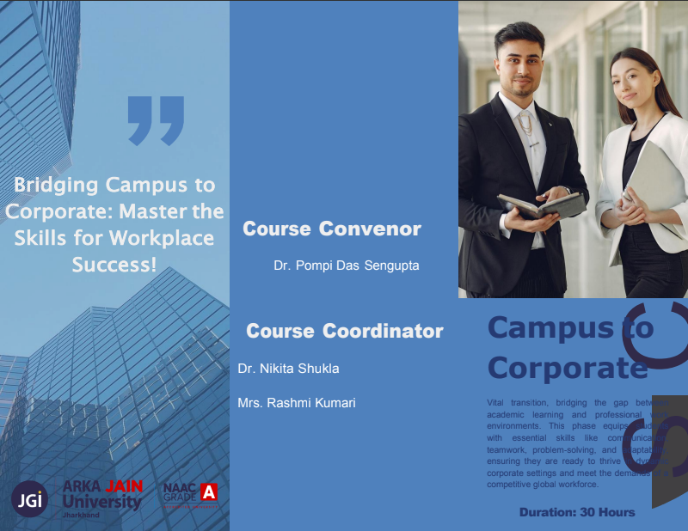

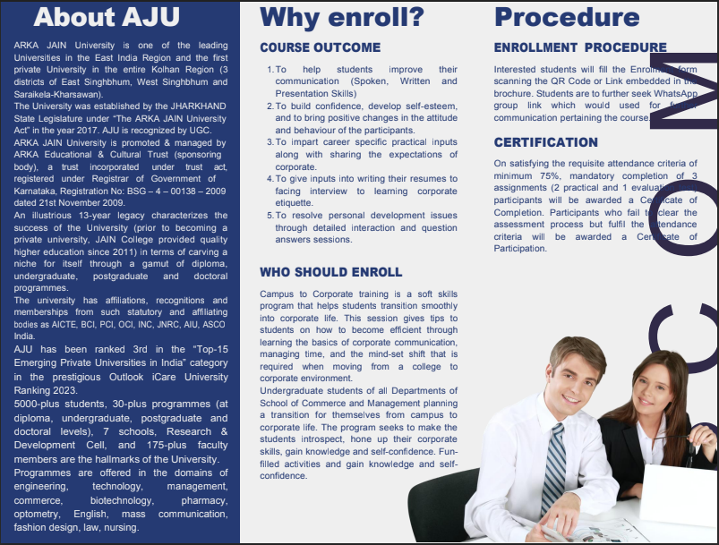
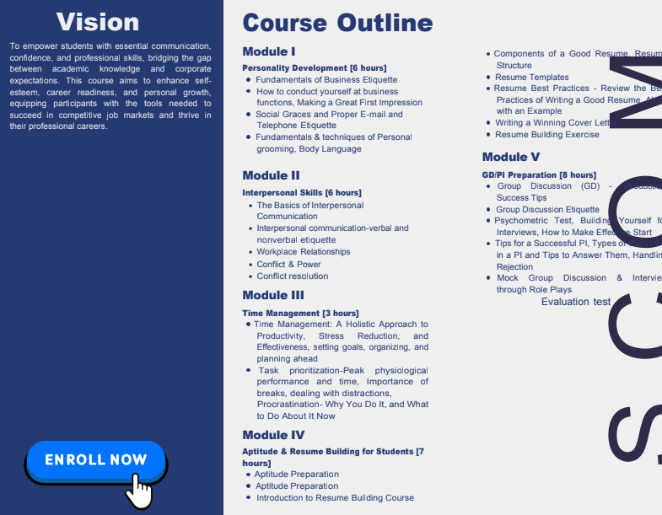

Figure 1 (b): Brochure of the Value Added Course

Photos of the Event

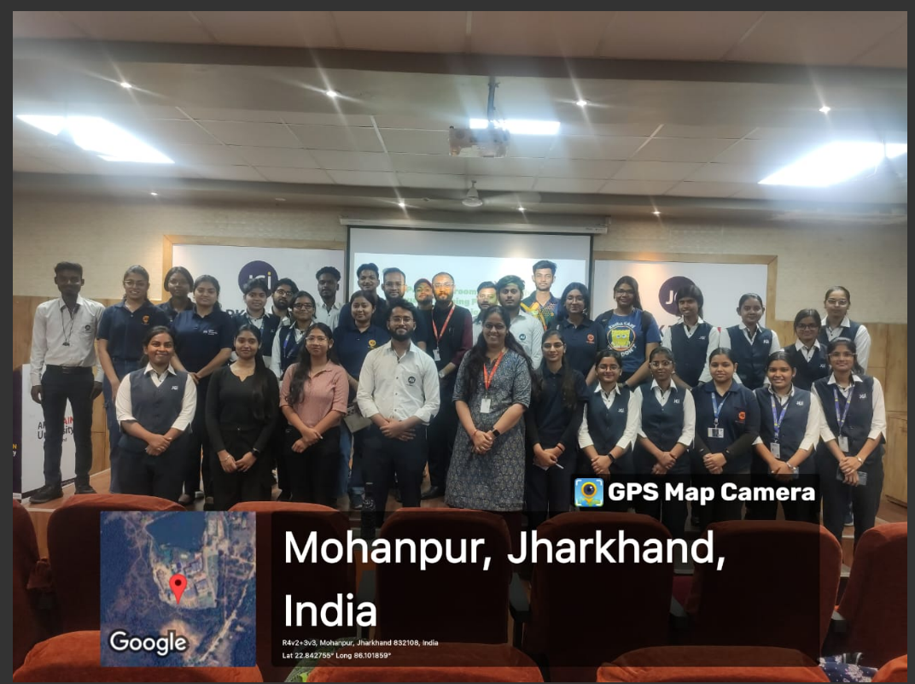

Figure 2: Group Photo of the Event

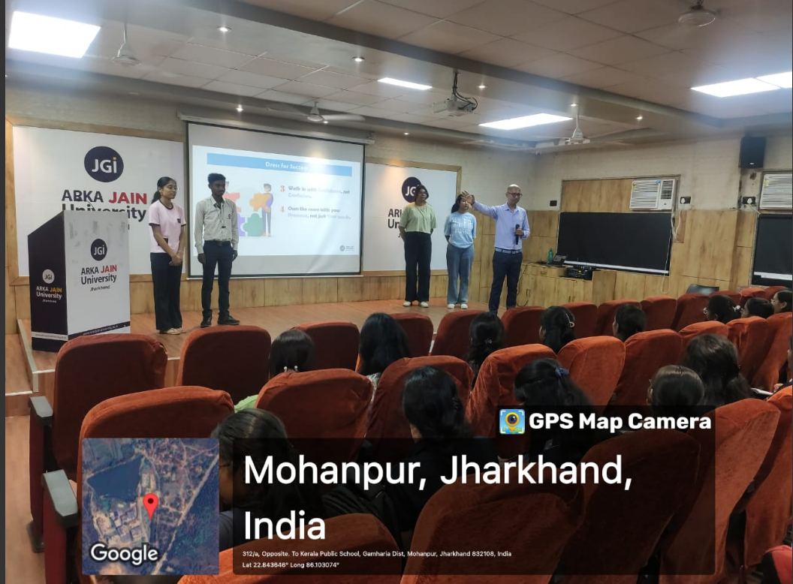
Figure 3: Guest Speaker Session

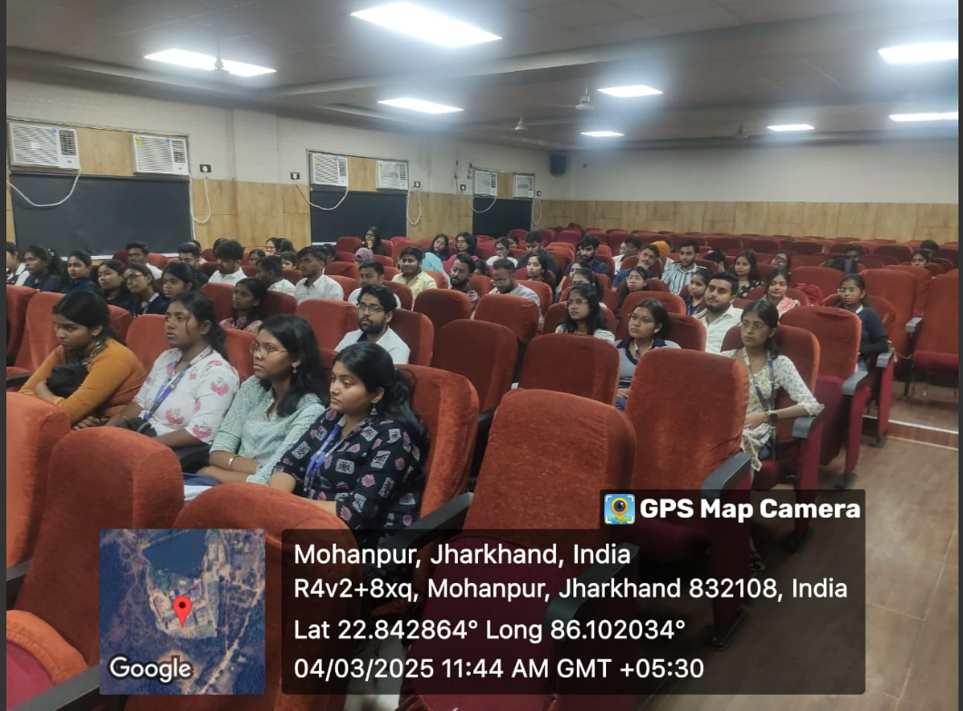

Figure 4 (b): Photo of the Event

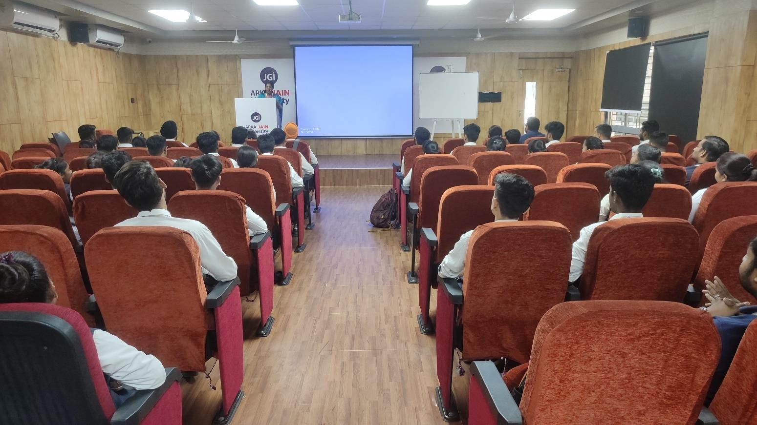
Figure 6: Photo of the Event

Figure 7: List of Participant

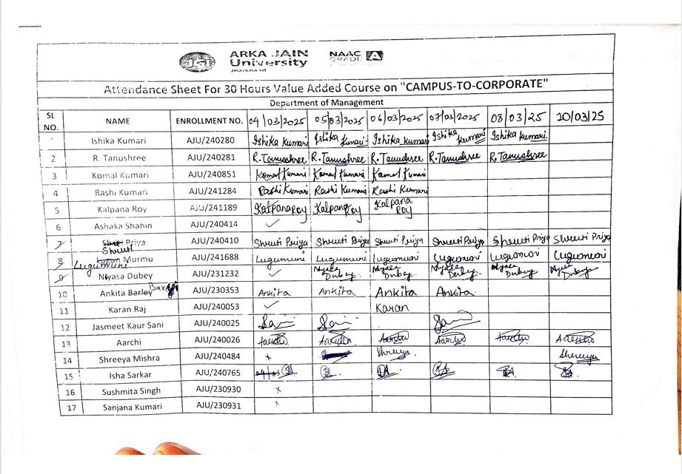

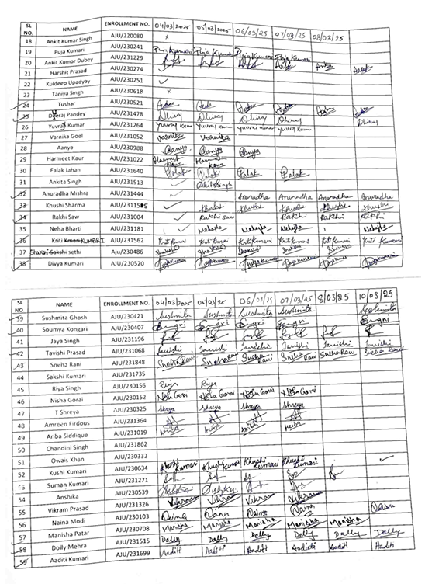
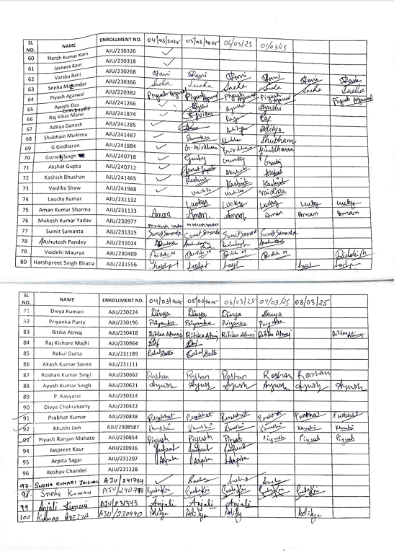
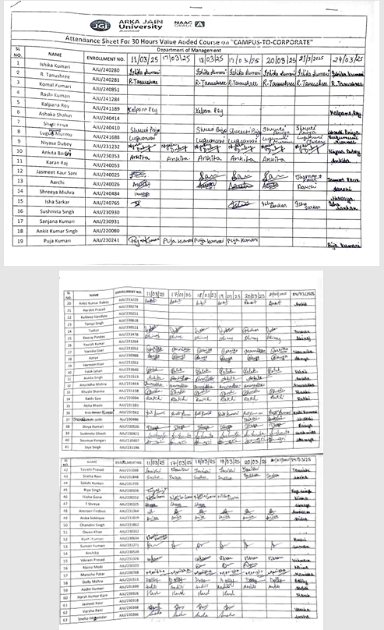

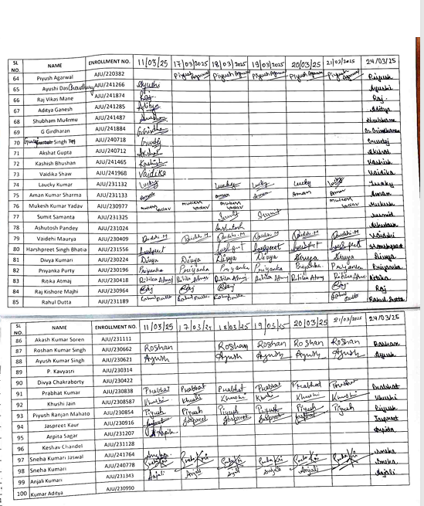
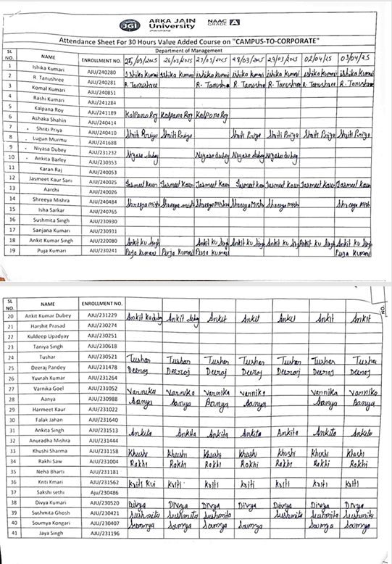
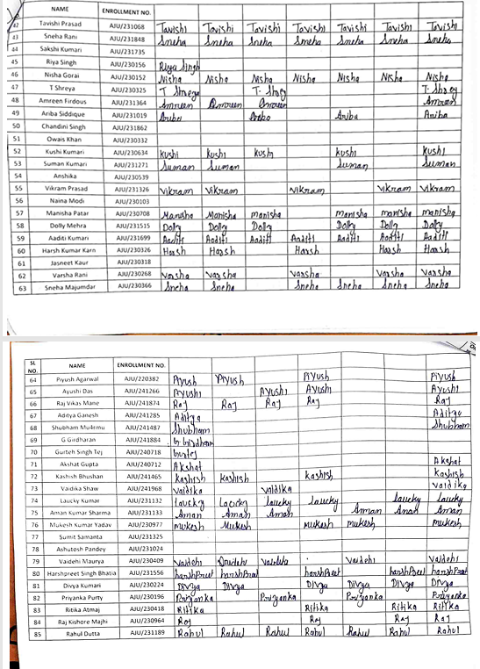
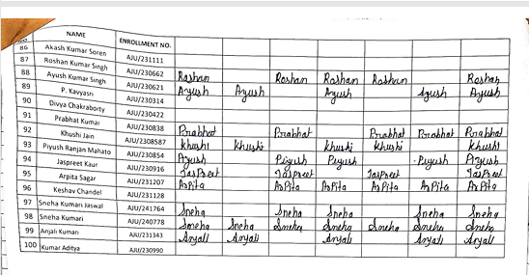

Exam Notice

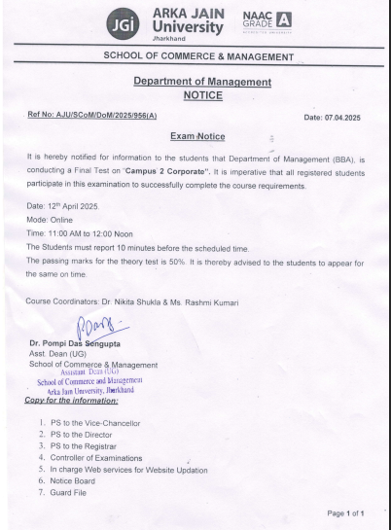

Figure 8: Students Participation Certificates

Student Feedback of Value Added Course- Campus to Corporate

