**EVENT NOTICE**

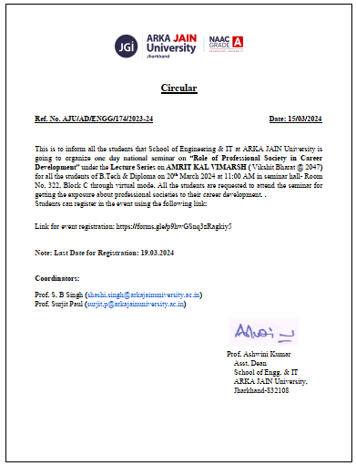

**ONE DAY NATIONAL SEMINAR ON “ROLE OF PROFESSIONAL SOCIETY IN CAREER  
DEVELOPMENT”**

|  |  |
| --- | --- |
| **Date of Event** | **20/03/24** |
| **Name and Type of Event** | **One day national seminar on “Role of Professional Society in Career Development”** |
| **Conducted by** | **Prof. Surjit Paul and Prof. S.B Singh** |
| **No. of Participants** | **114** |
| **Type of Event** | **Skill Development** |

**Objectives:** To provide knowledge about various professional societies and their benefits in career development.

The School of Engineering & IT organized one day national seminar under Lectures series on “AMRIT KAAL VIMARH (VIKSIT BHARAT @2047) "Role of professional societies in career development" on 20th March 2024 in Seminar Hall, Baudhyana Block C at 11 AM through virtual mode. The students of School of Engineering & IT actively participated in this event.

School of Engineering under the guidance of Dr. Ashwini Kumar and the coordination of Prof. Surjit Paul and Prof. S. B Singh organized one day national seminar on “Role of professional societies in career development”. The keynote speech was delivered by Prof. (Dr.) A.K Nayak and provided valuable insights about various professional societies of India to the students of B.Tech and Diploma to enhance their knowledge about professional societies and their role for career development.

The rules and regulations to join the online meeting were communicated through email to the participants prior to the event. A total of 114 students and faculty members and lab assistants had registered for the event and out of them 70 participants were present in the venue to witness the session. The lecture was quite interesting and students grasped the lecture. Finally students asked questions related to information security techniques at the end of the lecture.

**Expert Name:** Prof (Dr.) A K Nayak, Former President Computer Society of India and Advisor IIBM Group Patna.

**Short biography of the Expert:** Prof (Dr.) A.K Nayak was the former National President of Computer Society of India & Advisor of IIBM Group, Patna. He was the former director & Professor of Comp. SC. & IT of Indian Institute of Business Management, Patna. He is having more than 39 years of experience in teaching, training, research & administration in the field of Computer Science, Information Technology & Management. He was the former president of ICT section of Indian Science Congress Association & former Chairman of Indian Society for Technical Education Bihar- Jharkhand Section, Prof. Nayak is the Fellow of Computer Society of India, International Society for Research & Development, UK. He had authored 162 Papers, 12 Books, Edited 9 Books,10 proceedings of National & Internationals Conferences including Springer Publications, Received many international & National Awards and his Biography is published in 7 International Directories. Prof Nayak has worked as Expert Member of CEDTI Govt. of India, Reviewer of DST project, Govt. of India, Member. At present Prof. Nayak is the member of all India Board for IT education & board of Studies of Comp. Science & IT, AICTE, Govt, of india & Member of Bureau of Indian Standard, Govt. of India.

**Name of Student Coordinators:** Rohit Singh and Aman Kumar Keshri, (B.Tech CSE 1st Year)

**Outcome:** Students got an opportunity to gain insights about various professional societies and their benefits in career development.

**POSTER OF THE EVENT:**

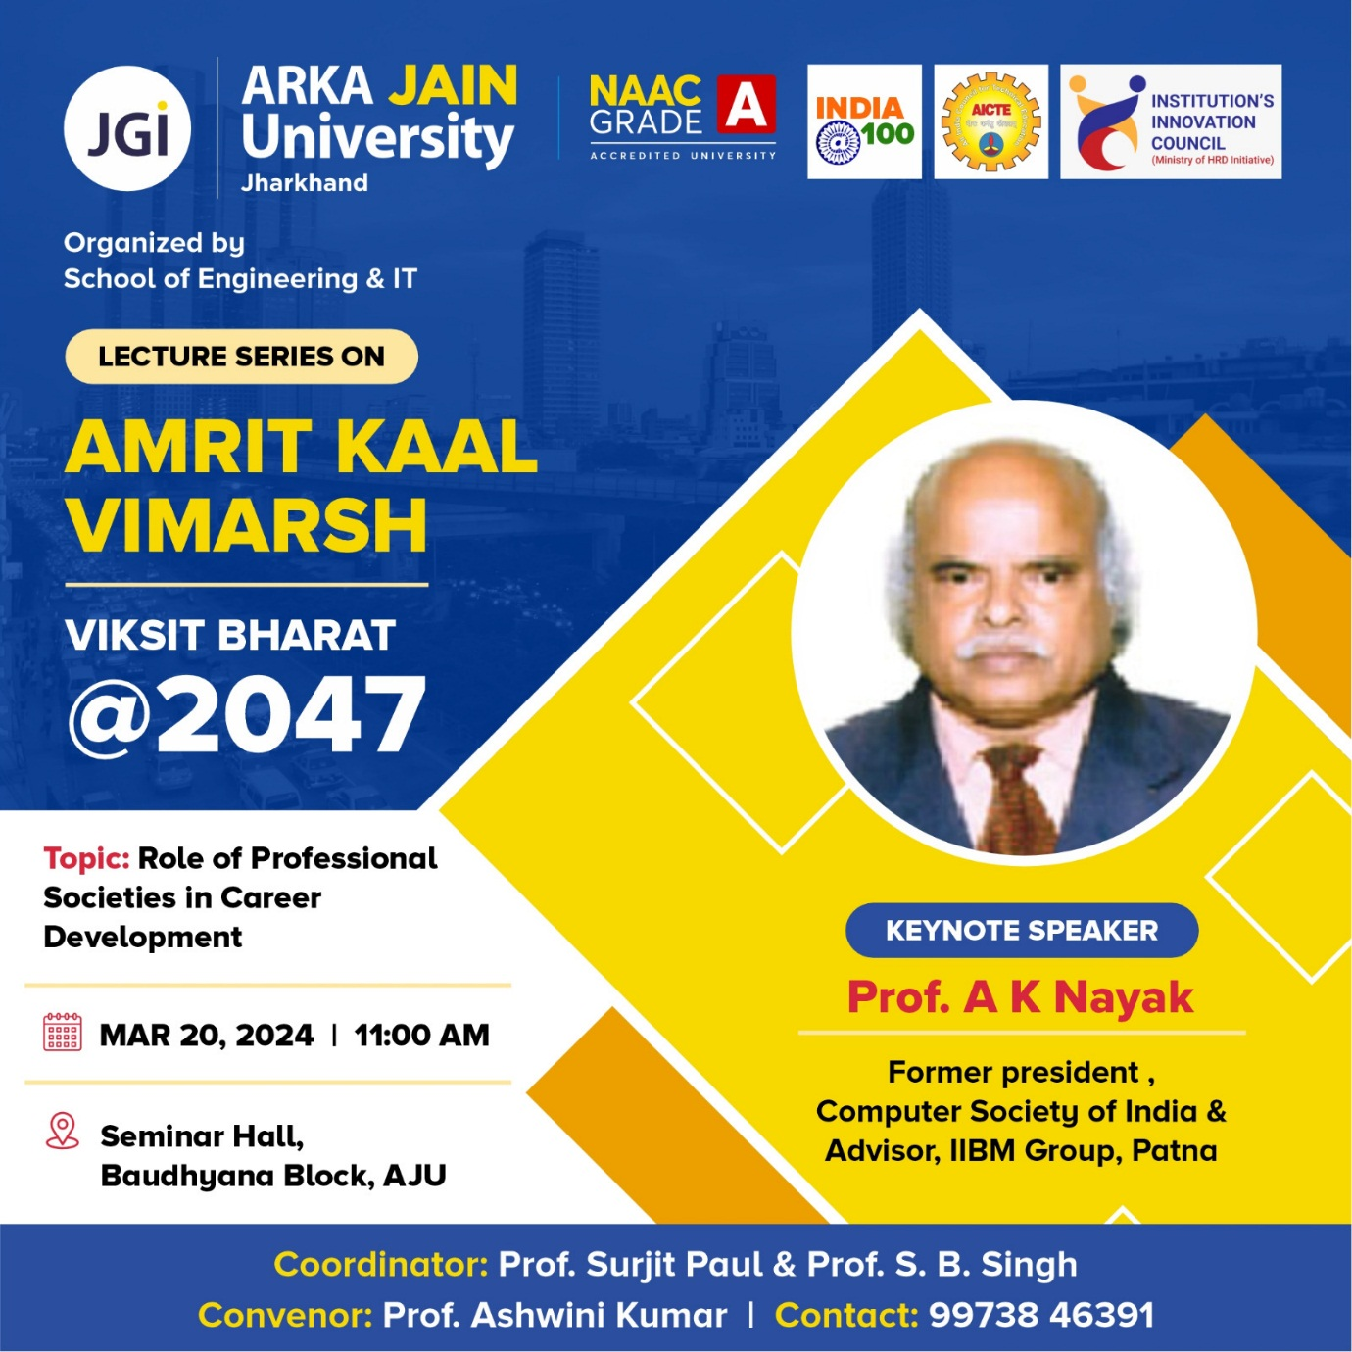

**PHOTOS OF THE EVENT:**

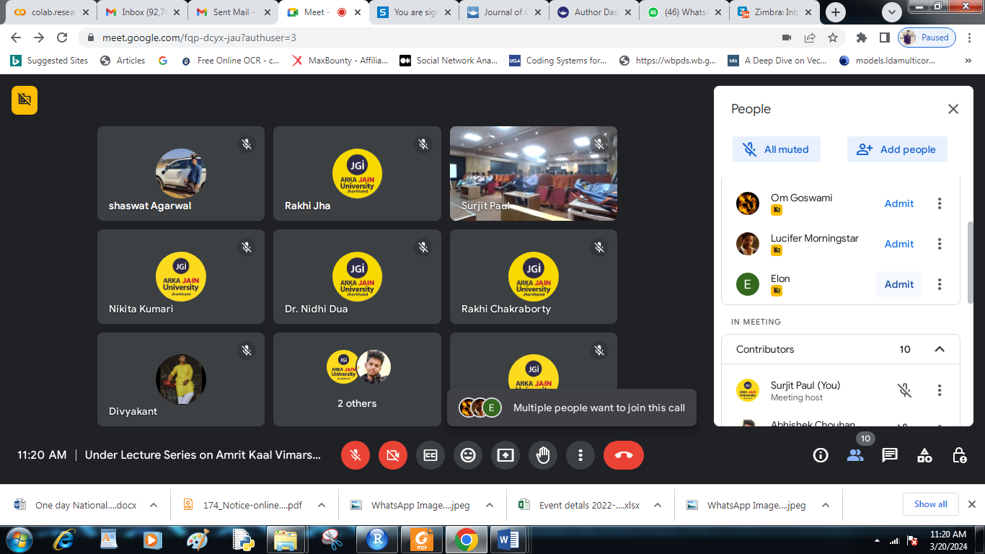

**Fig 1: Screenshot of the Event**

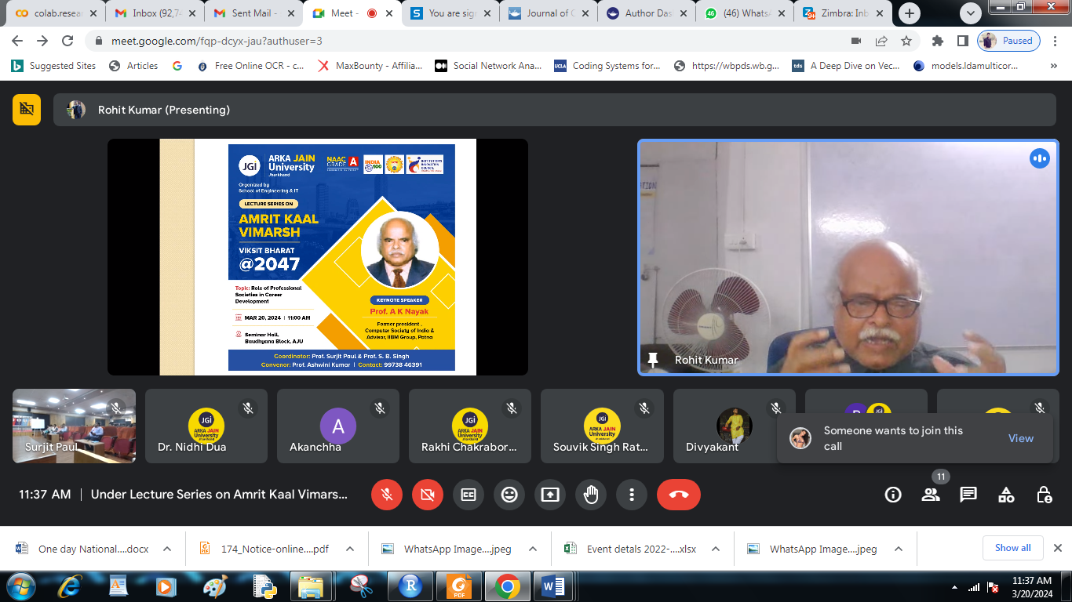

**Fig 2: Screenshot of the Event**

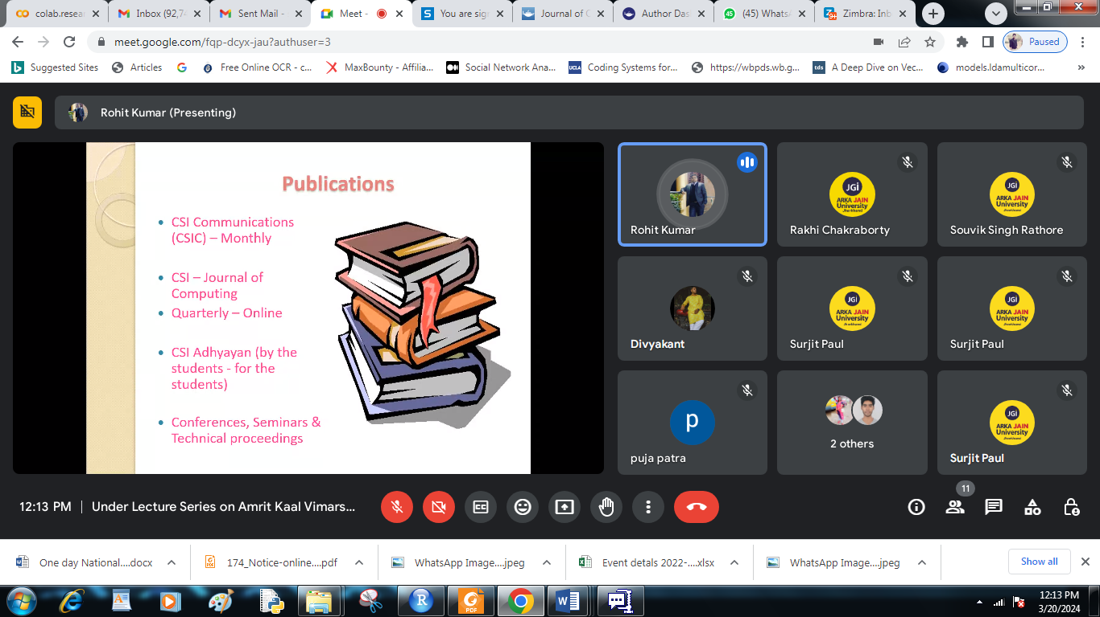

**Fig 3: Screenshot of the Event**

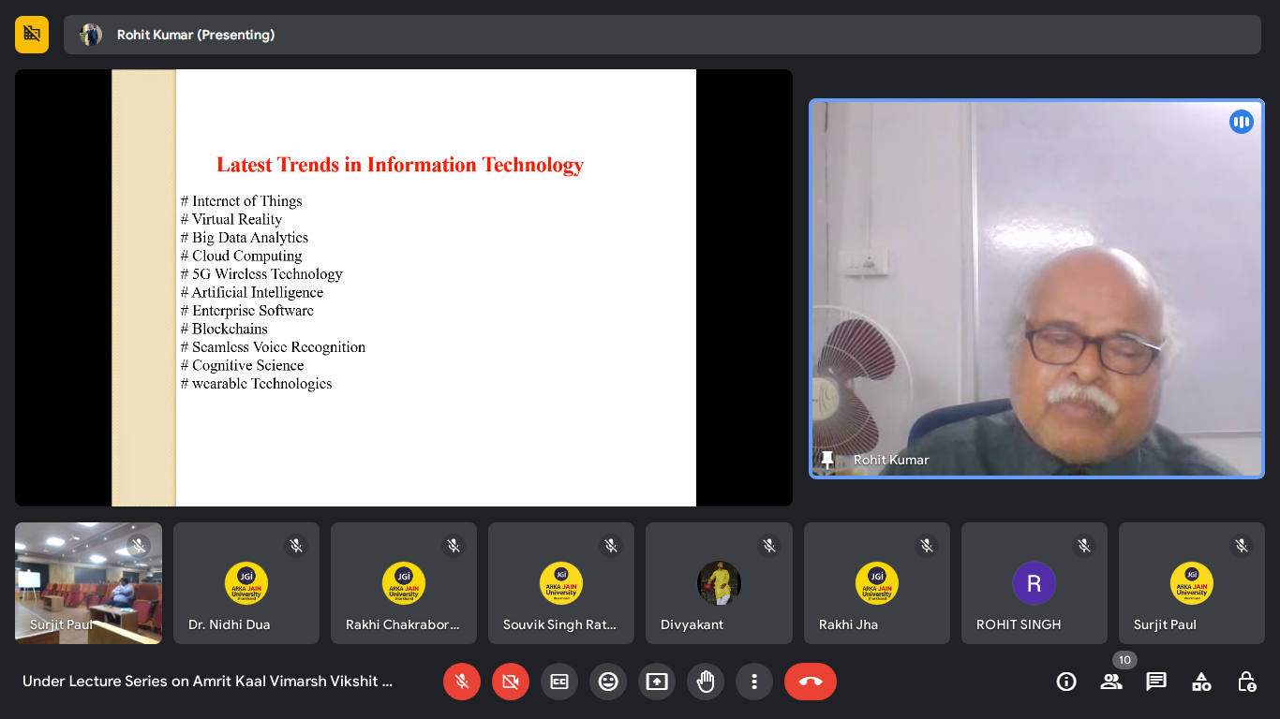

**Fig 4: Screenshot of the Event**

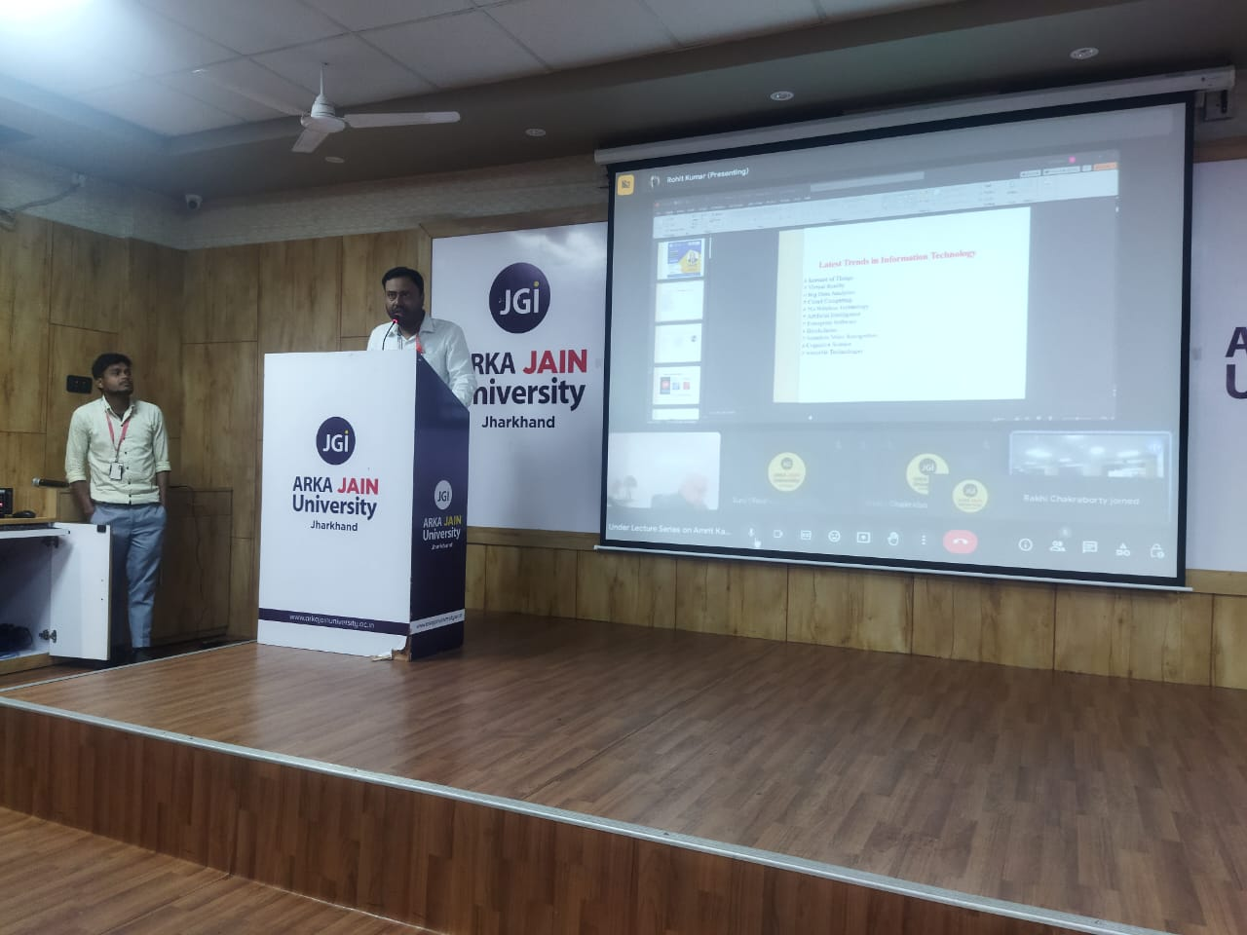

**Fig 5: Photos of the Event**

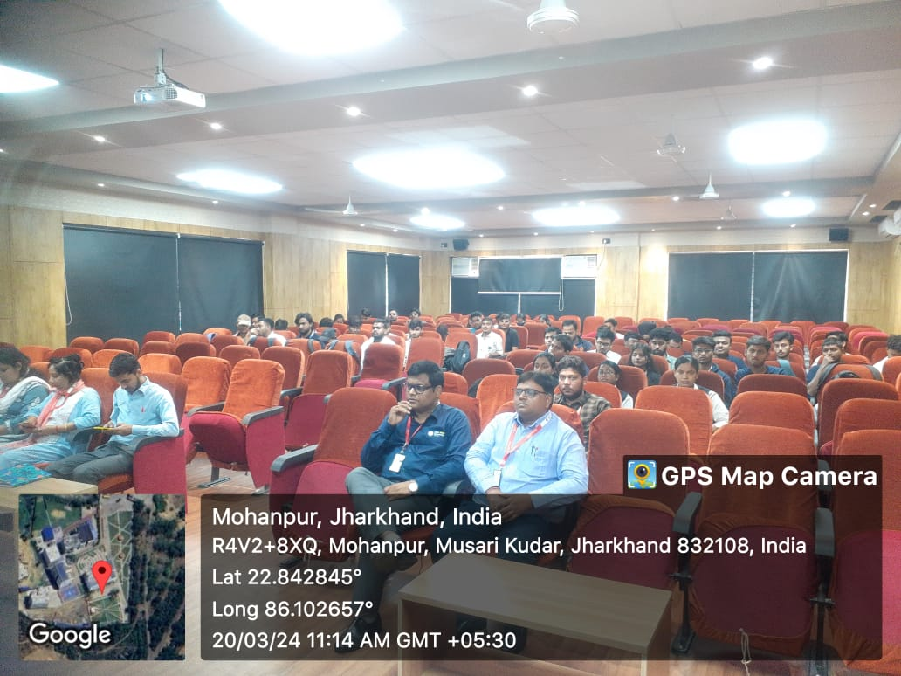

**Fig 6: Photos of the Event**

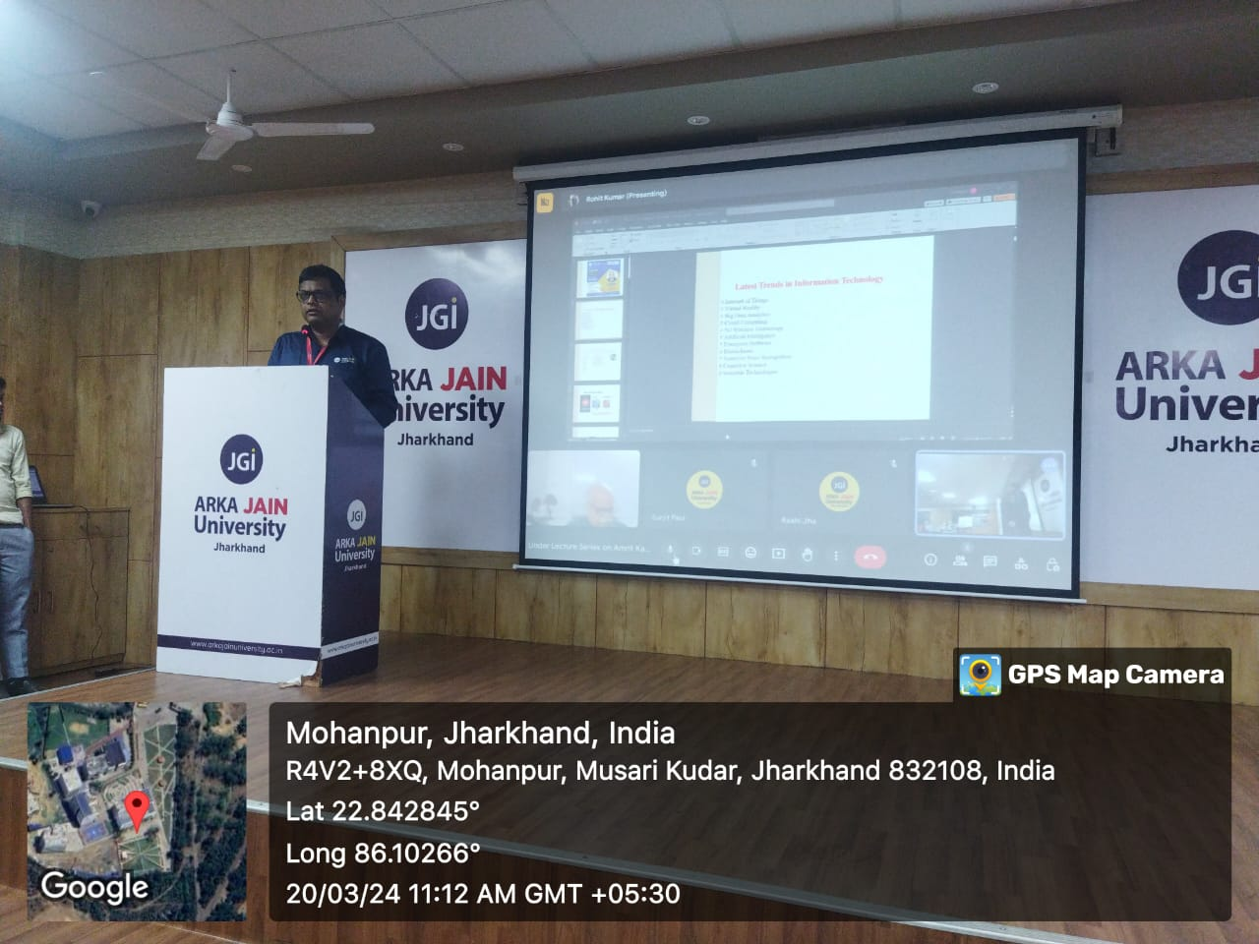

**Fig 7: Photos of the Event**

**PARTICIPANTS LIST:-**

|  |  |  |  |  |  |
| --- | --- | --- | --- | --- | --- |
| **Name** | **Designation** | **Enrollment No./Employee Id** | **Branch/**  **Dept** | **Email id** | **Contact No.** |
| Priti Kumari | Student | AJU/211383 | B.Tech CSE | kumarpriti383@gmail.com | 9122276268 |
| Ritu Mukhi | Student | AJU/211561 | Diploma CSE | Mukhiritu4@gmail.com | 9304480185 |
| Preeti Kiran Hessa | Student | AJU/211655 | B.Tech CSE | preetikiranhessa00@gmail.com | 8797003701 |
| Akanchha | Student | AJU/211101 | B.Tech CSE | akanchakumari791@gmail.com | 9334558897 |
| NIKITA KUMARI | Student | AJU/210947 | Diploma CSE | nikitakumari1331@gmail.com | 7684085565 |
| Puja Patra | Student | AJU/210081 | Diploma CSE | pujapatra25755@gmail.com | 7004580024 |
| Deepak Kumar | Student | AJU/211213 | B.Tech CSE | dkcreations1920@gmail.com | 9204560573 |
| MD Faisal Khan | Student | AJU/230974 | B.Tech ME | mohammadfaisalkhan9234@gmail.com | 7667835145 |
| Vivek pramanik | Student | Aju/231137 | M.Tech CSE | rp3514364@gmail.com | 9576121631 |
| Mousumi Paul | Student | AJU/201276 | B.Tech CSE | mousumipl12@gmail.com | 6204860338 |
| Mousumi Paul | Student | AJU/201276 | B.Tech CSE | mousumipl12@gmail.com | 6204860338 |
| Anish Kumar | Student | Aju/221559 | B.Tech CSE | manishsinghaniya8789@gmail.com | 8252317017 |
| Akash paul | Student | Aju/ 211440 | B.Tech CSE | ap0078022@gmail.com | 9934103986 |
| Samir Suman | Student | AJU,/220732 | B.Tech CSE | sumansamir2001@gmail.com | 9801862124 |
| Simee Pandey | Student | AJU/231845 | B.Tech CSE | simeepandey68@gmail.com | 9508106012 |
| Ritesh Kumar | Student | AJU/221403 | B.Tech CSE | riteshkumar90359@gmail.com | 6206269895 |
| Nikhil kumar pandey | Student | AJU/231616 | B.Tech ME | nikhilkumarjsr2000@gmail.com | 6200070593 |
| Romi Kumar | Student | AJU/222203 | Diploma EEE | romisoni441@gmail.com | 6205465366 |
| Vinay Kumar | Student | AJU/201221 | B.Tech CSE | kumarvinay18.vk@gmail.com | 8292132328 |
| Arshad Khan | Student | Aju/222117 | B.Tech EEE | ak3258528@gmail.com | 8102635539 |
| Sharique Ansar | Student | AJU/222132 | B.Tech EEE | shariqueansar633@gmail.com | 6200965349 |
| Akanchha | Student | AJU/211101 | B.Tech CSE | akanchakumari791@gmail.com | 9334558897 |
| Avishek Kumar | Student | AJU/221227 | B.Tech CSE | avrj101@gmail.com | 7903454421 |
| Varun mukhi | Student | Aju/222121 | B.Tech CSE | varun.guru23@gmail.com | 7541975139 |
| Sagarkumarsharma | Student | AJU211720 | B.Tech CSE | Sagarkumarsharma4243@gmail.com | 8709029190 |
| Kaushal Kumar Jha | Student | AJU/221191 | B.Tech CSE | Jhajikaushal8472@gmail.com | 9006133077 |
| Sristy Sen | Student | AJU/222176 | B.Tech CSE | Sristysen3@gmail.com | 6206883321 |
| Amit Kumar | Student | Aju/231362 | B.Tech CSE | amitkumar19000hii@gmail.com | 8409174555 |
| Mousumi Paul | Student | AJU/201276 | B.Tech CSE | mousumipl12@gmail.com | 6204860338 |
| Amar Das | Student | AJU/220948 | B.Tech CSE | daarav14@gmail.com | 9508156097 |
| Som parashar | Student | AJU/220968 | B.Tech CSE | somparashar361@gmail.com | 9905174607 |
| Simran Kumari | Student | AJU/200678 | B.Tech CSE | simransingh4903@gmail.com | 8797020086 |
| Akash Mishra | Student | AJU/222094 | B.Tech CSE | akashcrazy72@gmail.com | 8541009354 |
| Rohit Kumar sah | Student | AJU/210916 | B.Tech CSE | sahrohitkumar07@gmail.com | 7765031008 |
| Meehir Kumar mishra | Student | Aju/231338 | B.Tech CSE | meehir008@gmail.com | 6204330801 |
| Neeraj Kumar | Student | AJU/222181 | B.Tech CSE | mishrampu@gmail.com | 9798460836 |
| Honey Kumari | Student | Aju/200679 | B.Tech CSE | kumarihoneyy6@gmail.com | 9798027106 |
| Sanatan sahoo | Student | AJU/221547 | B.Tech CSE | sahoosanatan035@gmail.com | 8102847021 |
| DHEERAJ MAHAPATRA | Student | AJU/230467 | B.Tech CSE | dheerajmahapatra05@gmail.com | 9031558214 |
| Raja sahu | Student | AJU/231317 | B.Tech CSE | rajasahu9934@gmail.com | 6205918305 |
| Neeraj Kumar | Student | AJU/222181 | B.Tech CSE | mishrampu@gmail.com | 9798460836 |
| Kumkum Kumari | Student | AJU/230413 | B.Tech CSE | kumkummahto7@gmail.com | 9263185108 |
| Anupam shaw | Student | AJU/221100 | B.Tech CSE | anupamshaw02@gmail.com | 7903299683 |
| Shruti Kumari | Student | AJU/220654 | B.Tech CSE | kumarishruti31092003@gmail.com | 7366879644 |
| kanchan kumari | Student | AJU/231336 | B.Tech CSE | kumarikanchan1601@gmail.com | 9798969638 |
| KANIT IRFAN | Student | AJU/222123 | B.Tech EEE | kanitirfan7062@gmail.com | 6203541576 |
| Dr. Md Irfan Ahmed | Assistant Professor | 1530 | School of Engineering & IT | dr.irfan@arkajainuniversity.ac.in | 8294759336 |
| Rohit singh | Student | Aju/230329 | B.Tech CSE | rs21rohit@gmail.com | 8210072779 |
| MD NASIM ANSARI | Lab Assistant | 1544 | School of Engineering & IT | nasim.blit@gmail.com | 9852584748 |
| Isha singh | Student | AJU/222196 | B.Tech CSE | isha3842@gmail.com | 6287090426 |
| RAJ JET SONKAR | Student | AJU230759 | B.Tech CSE | kumarraj2122002@gmail.com | 7979781366 |
| Shashi Kumar Singh | Student | AJU/221035 | B.Tech CSE | shashikumarsingh9094@gmail.com | 9525180837 |
| Kunal Kumar | Student | AJU/210641 | B.Tech CSE | kunalkumar1787@gmail.com | 9304311381 |
| Mukesh Kumar Sharma | Assistant Professor | 1230 | School of Engineering & IT | mukesh.s@arkajainuniversity.ac.in | 9040875250 |
| Souvik Singh Rathore | Assistant Professor | ARKA/AJU/1635 | School of Engineering & IT | souvik.r@arkajainuniversity.ac.in | |
| Manjur Ansari | Assistant Professor | Arka/Aju/1656 | School of Engineering & IT | manjuransari86@gmail.com | 9572355540 |
| MD TOUFIQUE KHAN | Student | AJU/221437 | B.Tech CSE | khantoufique2018@gmail.com | 8987419028 |
| Sibtain Raza | Student | AJU/221722 | Diploma CSE | khanbhai14063@gmail.com | 9330849093 |
| Adarsha Rana | Assistant Professor | 1655 | School of Engineering & IT | adarsharana2021@gmail.com | 7501585818 |
| MD RAJA KHAN | Student | AJU/210064 | B.Tech CSE | mdrajakhan3268@gmail.com | 9065435112 |
| Uday Kumar Thakur | Student | AJU/221173 | Diploma CSE | ukumarjr04@gmail.com | 9065617844 |
| Sayeed Anwar | Student | AJU/201154 | B.Tech CSE | anwarsayeed14121998@gmail.com | 8789658057 |
| Aman Kumar | Student | 201196 | B.Tech CSE | amankumar29101999@gmail.com | 7488192260 |
| Shubham Kumar Singh | Student | AJU/220739 | B.Tech CSE | shubhamkumarsingh8721@gmail.com | 7079050708 |
| MOHIT PATRO | Student | AJU/231434 | B.Tech CSE | mohitpatro58@gmail.com | 7485816773 |
| Kumari Isha | Student | AJU/230390 | B.Tech CSE | eshak3265@gmail.com | 7463064177 |
| Rupsa Singh | Student | AJU/201251 | B.Tech CSE | rupsasingh65@gmail.com | 9262763745 |
| SHYAM KUMAR SONI | Student | AJU/230574 | B.Tech CSE | piyush.soni8877@gmail.com | 8877471116 |
| Shivam Kumar jha | Student | Aju/210915 | B.Tech CSE | shivamjha3963@gmail.com | 7209602087 |
| Dhruv Shekhar | Student | AJU/230561 | B.Tech CSE | dhruvshekhar3@gmail.com | 9955291112 |
| Kuldip kumar sahu | Assistant Professor | 1106 | School of Engineering & IT | dr.kuldip@arkajainuniversity.ac.an | 870934243 |
| Rajiu Kr Prasad | Student | AJU/201192 | B.Tech CSE | rajivkumaprasad245@gmail.com | 7779825319 |
| Sandeep kumar | Student | AJU/221086 | B.Tech CSE | sandeepkumar.700477@gmail.com | 9334532183 |
| Anurag Kumar rai | Student | AJU/231342 | B.Tech CSE | anuragkumarr29@gmail.com | 7061688191 |
| Sahil kumar | Student | 210959 | B.Tech CSE | sahilkumarchandravanshi27@gmail.com | 9608769366 |
| Dr Binod Kumar Choudhary | Associate Professor | 1110 | School of Engineering & IT | dr.binod@arkajainuniversity.ac.in | 9939974938 |
| Manaswita Sharma | Assistant Professor | 1538 | School of Engineering & IT | manaswita.s@arkajainuniversity.ac.in | 7765055982 |
| Chandan Kumar | Student | AJU/231610 | B.Tech CSE | rk7969883@gmail.com | 6201766018 |
| Chirag kumar | Student | AJU210710 | B.Tech CSE | Chiragsinghrajpoot321@gmail.com | 8178714129 |
| Md Arshad | Student | ARKA/AJU/1649 | B.Tech ME | arshad@arkajainuniversity.ac.in | 9264185383 |
| Abhijit Mandal | Lab Assistant | ARKA/AJU/1231 | School of Engineering & IT | abhijit.m@arkajainuniversity.ac.in | 7717706044 |
| Sweta Kumari | Student | AJU/211623 | B.Tech CSE | swetakumarijsr2002@gmail.com | 9341262448 |
| Suraj kumar | Assistant Professor | 1401 | School of Engineering & IT | suraj.kumar@arkajainuniversity.ac.in | 7004620732 |
| Rakhi Jha | Assistant Professor | 1439 | School of Engineering & IT | rakhi.j@arkajainuniversity.ac.in | 9861625206 |
| Dr. Nidhi Dua | Assistant Professor | 1479 | School of Engineering & IT | dr.nidhi@arkajainuniversity.ac.in | 6260173673 |
| Rakhi Chakraborty | Assistant Professor | ARKA/AJU/1224 | School of Engineering & IT | rakhi.c@arkajainuniversity.ac.in | 9835878243 |
| Suraj kumar | Assistant Professor | 1401 | School of Engineering & IT | Suraj.kumar@arkajainuniversity.ac.in | 7004620732 |
| Rohit Raj | Student | Aju/222188 | B.Tech CSE | rohitraj2k04@gmail.com | Null |
| Nitesh Tiwari | Student | AJU/222187 | B.Tech CSE | niteshtiwari0234@gmail.com | 7858950825 |
| Saima Farheen | Student | Aju/221887 | B.Tech CSE | saimafarheen1201@gmail.com | 6206014620 |
| Seema Mahato | Student | AJU/220430 | B.Tech CSE | seemamahato704@gmail.com | 8709456233 |
| Rohitkumar | Student | AJU/221756 | B.Tech CSE | Kumarrohitsingh650@gmail.com | 6206262071 |
| Awais Raza | Student | AJU/220814 | B.Tech CSE | sr5662844@gmail.com | 7488786759 |
| Sima Mahato | Student | AJU/220903 | B.Tech CSE | sima31453@gmail.com | 8521976635 |
| HARPREET SINGH | Student | AJU/221259 | B.Tech CSE | amarjeetsingh5411jsr@gmail.com | 9234374628 |
| IQBAL ashraf | Student | AJU220844 | B.Tech CSE | alkllweb22@gmail.com | 8404915676 |
| ARJUN SINGH | Student | AJU/220245 | B.Tech CSE | 7061309625arjun@gmail.com | 7061309625 |
| Shaswat Agarwal | Student | Aju/220052 | B.Tech CSE | shaswatagarwal34@gmail.com | 8434104940 |
| ANIKET KUMAR | Student | AJU/221284 | B.Tech CSE | aniketkumar72004@gmail.com | 8797075994 |
| Debasish Pal | Student | AJU/221661 | B.Tech CSE | debasishpal765@gmail.com | 7296085829 |
| Gaurav Kumar Suman | Student | AJU/221960 | B.Tech CSE | kumargaurav9142@gmail.com | 9142318615 |
| TUSHAR KUMAR DAS | Student | AJU/220156 | B.Tech CSE | tusharkumardas1125@gmail.com | 9102983110 |
| Raj Kumar | Student | AJU/221714 | B.Tech CSE | rajkumarswansi01@gmail.com | 8201419744 |
| Adarsh kumar | Student | AJU/220108 | B.Tech CSE | Rnagia7@gmail.com | 9572760657 |
| Pramod Nayak | Student | AJU/220725 | B.Tech CSE | nayakpramod956@gmail.com | 6200270035 |
| Sudhanshu singh | Student | AJU/221513 | B.Tech CSE | sudhanshusingh4244@gmail.com | 9386445841 |
| MOHAMMAD NABEEL ASRAR | Student | AJU/222120 | B.Tech CSE | mdnabeel315@gmail.com | 8797466364 |
| Yuvraj | Student | AJU/221306 | B.Tech CSE | yuvraj7847@gmail.com | 9608076974 |
| Om goswami | Student | AJU/220949 | B.Tech CSE | omgoswami.jsr2007@gmail.com | 9142962007 |
| Abhishek Chouhan | Student | AJU/210566 | B.Tech CSE | abhishekchouuan@gmail.com | 9155063300 |
| Gourav Kumar Pandey | Student | AJU/220728 | B.Tech CSE | pandeygourav2002@gmail.com | 6207097548 |
| Mukesh kumar | Student | AJU/221536 | B.Tech CSE | mukesh2468b@gmail.com | 7779818770 |
| Divyakant | Student | AJU/210560 | B.Tech CSE | divyakant38@gmail.com | 7004981750 |
| Ankit Kumar Singh | Student | Aju/221026 | B.Tech CSE | avtarankit@gmail.com |  |

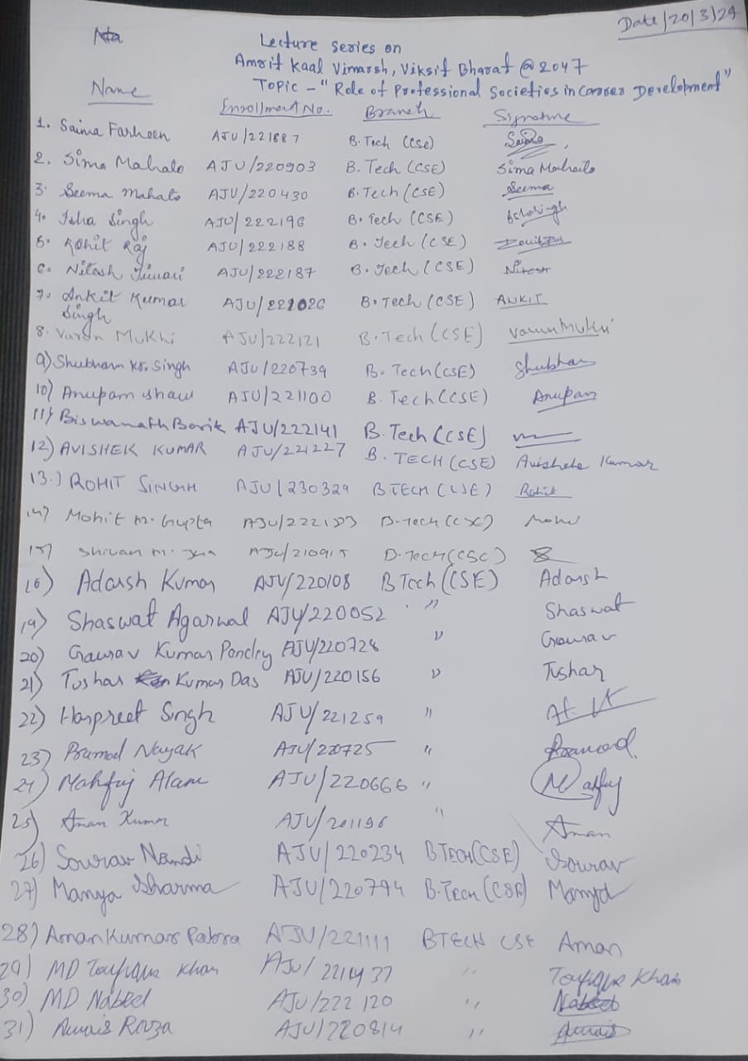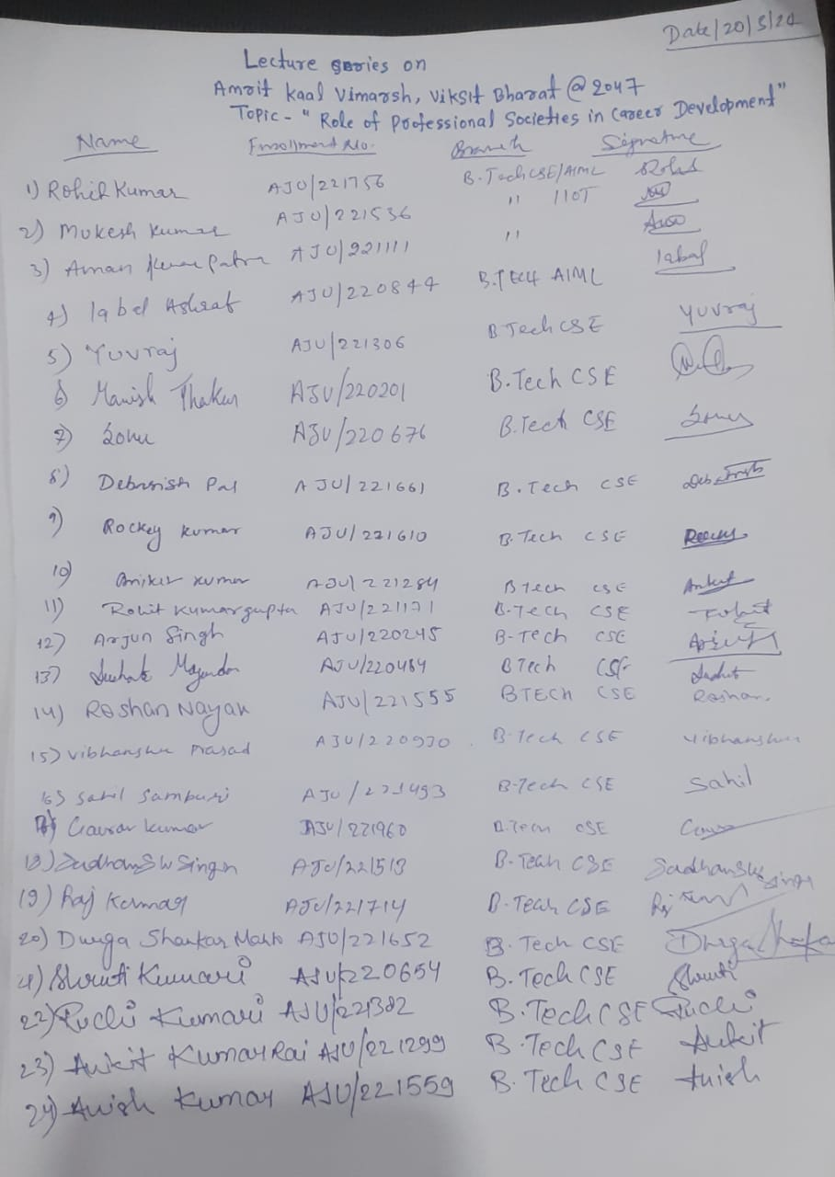

**EXPERT CERTIFICATE:**

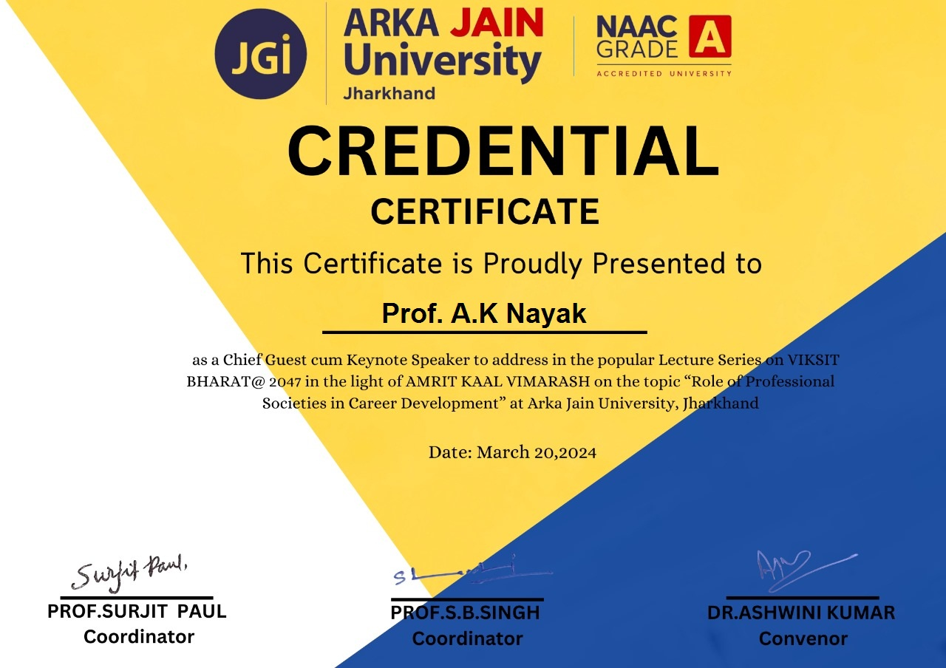

**SAMPLE PARTICIPATION CERTIFICATES:**

