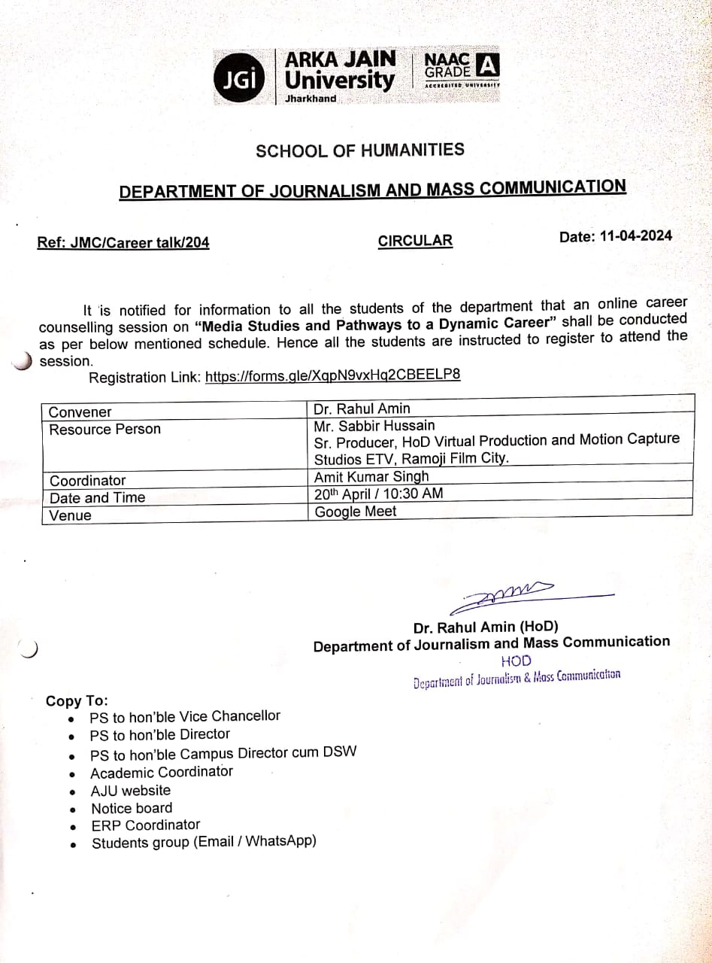

Online Career Counseling Session on Media Studies & Pathways to a Dynamic Career

Date of Event | 20.04.2024
Name of Event | Online Career Counseling Session on Media Studies & Pathways to a Dynamic Career.
Type of the event | Skill Development, Participative Learning and  Entrepreneurship Development.
Conducted by | Department of Journalism and Mass Communication
Resource Person | Mr. Sabbir Hussain  Sr. Producer, HoD Virtual Production  And Motion Captures Studios ETV,  Ramoji Film City, Hyderabad.
No. of Participants | 32
OBJECTIVE: To make the students learn about the career dynamics in the field of
Journalism and Mass Communication and to provide the students relevant information in
the realm of virtual production and motion graphics.

DETAILS: Department of Journalism and Mass Communication in association with Training and Placement department of Arka Jain University organized an online session on career counseling. The speaker of the session was Mr. Sabbir Hussain, Sr. Producer, HoD Virtual Production and Motion Captures Studios ETV, Ramoji Film City Hyderabad.

This session was started by Mr. Amit Kumar Singh Assistant Professor, Department of Journalism and Mass Communication by welcoming the resource person. Mr. Sabbir Hussain took the session on current shift of the media industry towards the graphics and animation and gave the insights on how these graphics and new media are the new paradigm on the media and entertainment industry. He explained the different voids on which the media and communication learners are absorbed as employees and has also put light on the multiple skills to be developed for better engagement in the industry.

The Chairman of Arka Jain University, Professor Dr. S. S. Razi, Registrar and Director Dr. Amit Kumar Shrivastav, Dean-Student Welfare, Professor Dr. Angad Tiwari and Joint Registrar Dr. Jasbir Singh Dhanjal, deans and Heads of Departments and faculty members of various departments were present during the session. During this session, Dr. Rahul Amin, Head of the Department of Journalism and Mass Communication, said the students that 'It is important to understand the shift in the media industry so that we could keep ourselves abreast of the upcoming technology and make the students aware of the new trends and technology’. This special session was very beneficial for all the students.

Guest speaker Mr. Sabbir Hussain expressed sincere gratitude towards the AJU management and participants for inviting him and making this event a grand success.

OUTCOMES: The session was productive for all the students. All the students got
guidance related to career and studies.

Poster of the Event

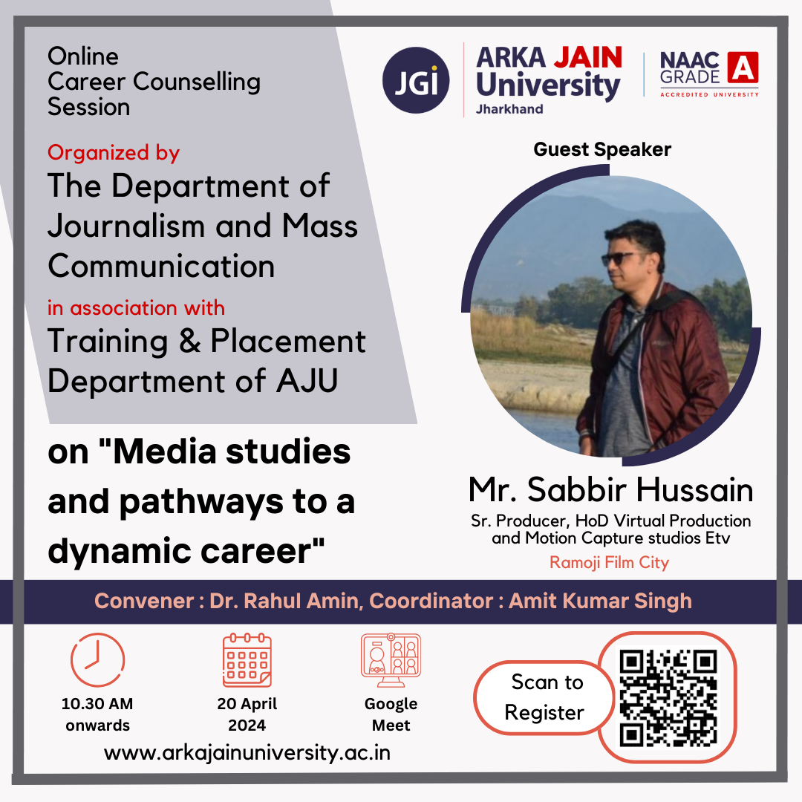
Figure 1: Poster of online career counseling session

Photos of the Event
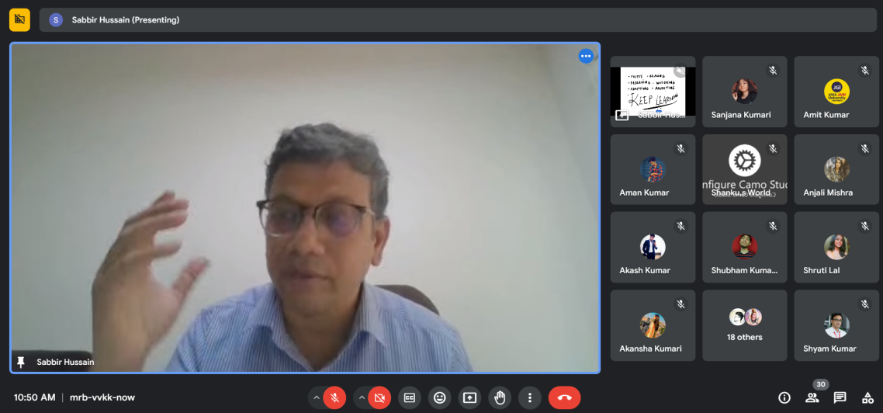

Figure 2: Guest Speaker Mr. Sabbir Hussain taking Online Career Counseling Session

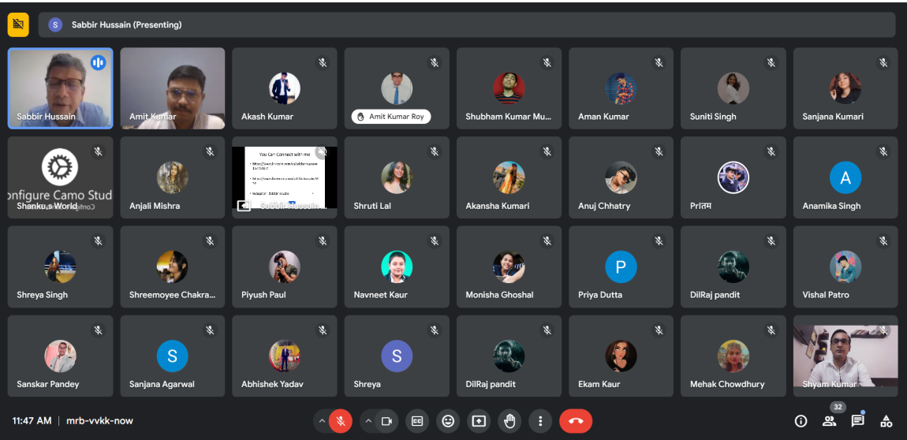

Figure 3: Attendees of the Online Career Counseling Session

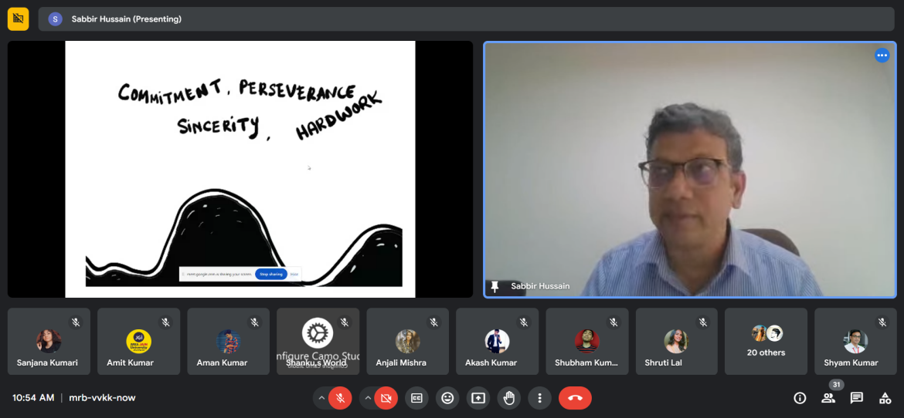

Figure 4: Guest Speaker Mr. Sabbir Hussain discussing on career related topic during online session

List of Participants

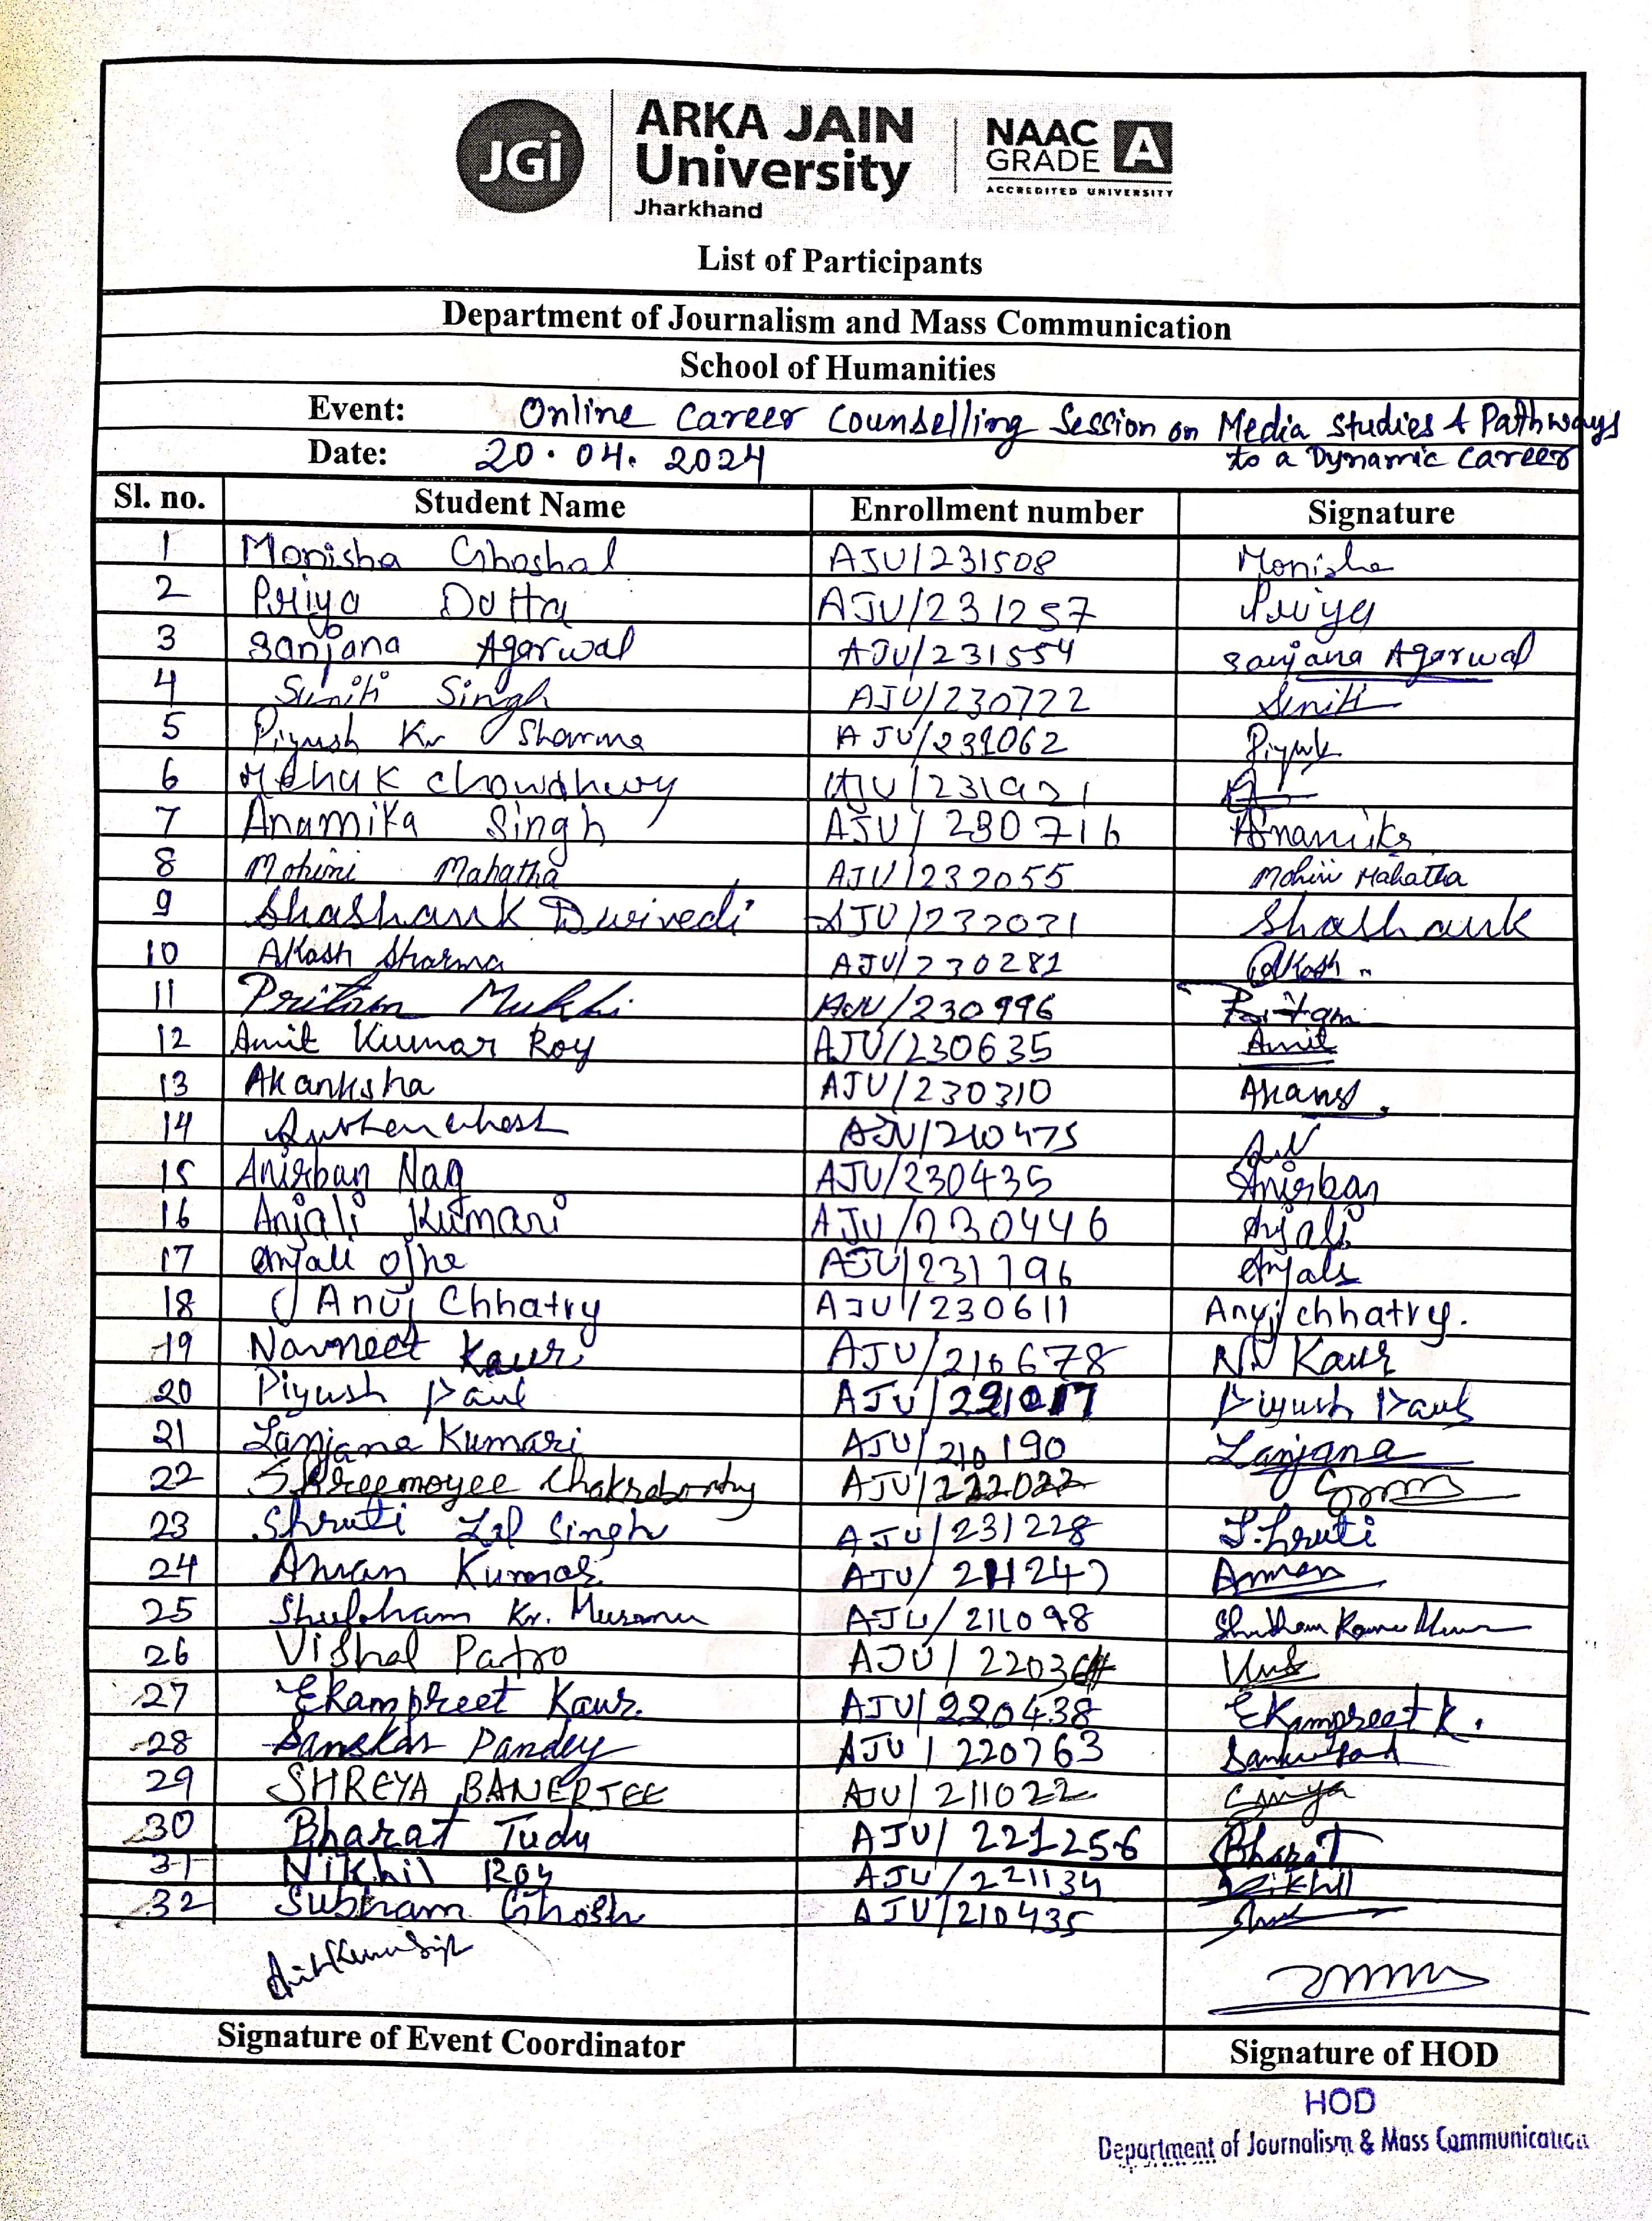

Feedback analysis on online session online Career Counseling Session on Media Studies & Pathways to a Dynamic Career
